AI ASSISTED CODING

LAB ASSIGNMENT-13.3
2403A510C3-BATCH05
Lab 13 – Code Refactoring: Improving Legacy Code with AI
Suggestions

Task Description #1 – Remove Repetition
Task: Provide AI with the following redundant code and ask it to
refactor

PROMPT:

REFACTOR
Python Code
def calculate_area(shape, x, y=0):
if shape == "rectangle":
return x * y
elif shape == "square":
return x * x
elif shape == "circle":
return 3.14 * x * x
Expected Output:
Refactored version with dictionary-based dispatch or separatefunctions.Cleaner and modular design.

GENERATED CODE:

import math

def area_rectangle(length, width):
return length * width

def area_square(side):
return side * side

def area_circle(radius):
return math.pi * radius * radius

# Dictionary dispatch for shape selection
AREA_CALCULATORS = {
"rectangle": area_rectangle,
"square": area_square,
"circle": area_circle
}

def calculate_area(shape, x, y=0):
shape = shape.lower()
if shape not in AREA_CALCULATORS:
raise ValueError(f"Unsupported shape: {shape}")

if shape == "rectangle":
return AREA_CALCULATORS[shape](x, y)
else:
return AREA_CALCULATORS[shape](x)

OUTPUT:
50
16
28.274333882308138

OBSERVATION:
The original implementation uses a chain of if-elif statements, which works but quickly becomes harder to manage as more shapes are added. It also hardcodes 3.14 for circle calculations, reducing accuracy. The refactored version separates the logic into dedicated functions for each shape and introduces a dictionary-based dispatch system. This makes the design modular, easier to extend, and more readable. By simply adding a new function and updating the dictionary, new shapes can be supported without cluttering the main function. Additionally, using math.pi improves precision, and the overall structure is cleaner, more maintainable, and better suited for scaling.

Task Description #2 – Error Handling in Legacy Code
Task: Legacy function without proper error handling

PROMPT:
Python Code
def read_file(filename):
f = open(filename, "r")
data = f.read()
f.close()
return data
Expected Output:
AI refactors with with open() and try-except:

GENERATED CODE:
def read_file(filename):
try:
with open(filename, "r") as f:
data = f.read()
return data
except FileNotFoundError:
return f"Error: The file '{filename}' was not found."
except Exception as e:
return f"An error occurred: {e}"

OUTPUT:
Error: The file 'missing.txt' was not found.

OBSERVATION:
The original code opens and closes the file manually, which works but risks leaving the file open if an error occurs. It also lacks error handling, so the program would crash if the file is missing or inaccessible. The refactored version improves reliability by using with open(), which ensures the file closes automatically, and adds try-except blocks to handle common errors gracefully. This makes the function safer, cleaner, and more robust for real-world use.

Task Description #3 – Complex Refactoring
Task: Provide this legacy class to AI for readability and modularity
improvements:

PROMPT:
class Student:
def __init__(self, n, a, m1, m2, m3):
self.n = n
self.a = a
self.m1 = m1
self.m2 = m2
self.m3 = m3
def details(self):
print("Name:", self.n, "Age:", self.a)
def total(self):
return self.m1+self.m2+self.m3\
Expected Output:
• AI improves naming (name, age, marks).
• Adds docstrings.
• Improves print readability.
• Possibly uses sum(self.marks) if marks stored in a list.

GENERATED CODE:
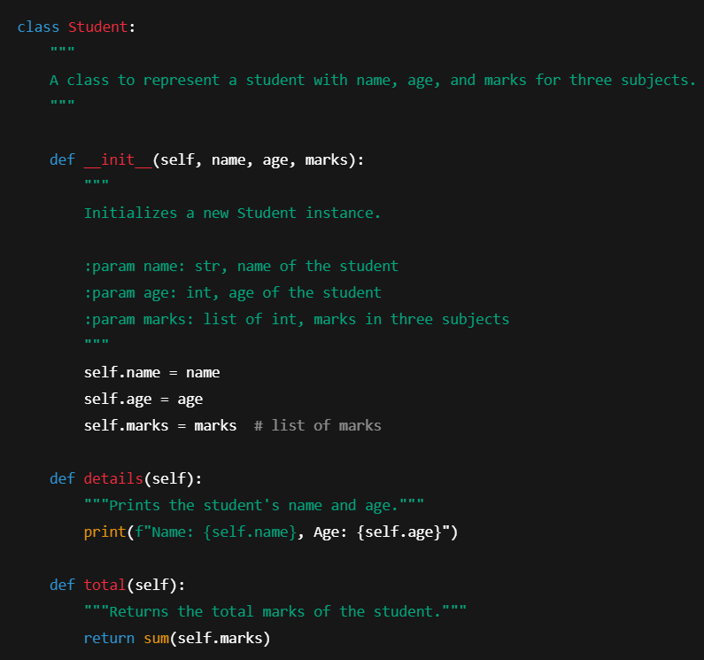

OUTPUT:
Name: Alice, Age: 20
Total Marks: 253

OBSERVATION:
The original Student class had unclear variable names (n, a, m1, m2, m3) and handled marks individually, making it less flexible. The refactored version improves readability with descriptive names (name, age, marks), stores marks in a list for scalability, adds docstrings for clarity, and uses sum(self.marks) to compute the total. Print statements are also cleaner, making the class more maintainable and easier to extend.

Task Description #4 – Inefficient Loop Refactoring
Task: Refactor this inefficient loop with AI help

PROMPT:
Refactor this inefficient loop
Python Code
nums = [1,2,3,4,5,6,7,8,9,10]
squares = []
for i in nums:
squares.append(i * i)
Expected Output: AI suggested a list comprehension

GENERATED CODE:
nums = [1, 2, 3, 4, 5, 6, 7, 8, 9, 10]
# Refactored using list comprehension
squares = [i * i for i in nums]
print(squares)

OUTPUT:
[1, 4, 9, 16, 25, 36, 49, 64, 81, 100]

